ABCA Team Academic Excellence Award Recipients
Congratulations to the GCC Baseball Team and Coach Ed Trujillo who have been honored by the American Baseball Coaches Association for their academic excellence. The GCC Baseball Team have been awarded the ABCA Team Academic Excellence Award for the 2018-2019 season, awarded to Baseball teams who maintain a cumulative team GPA of at least 3.00. View the complete list of recipients.

2019 Baseball NJCAA All-Academic Recipients
Congratulations to our student athletes:
- Dawson McCarville - 1st Team
- Dylan Bonzo - 1st Team
- Johnny Cherpak - 2nd Team
- Daniel Kamins - 2nd Team
- Carter Rhoades - 3rd Team
- Nick Rogers - 3rd Team
- Grant South - 3rd Team
- Nick Schouten - 3rd Team
- Zach Baptist - 3rd Team

Congratulations: GCC Players Who Will Be Continuing Their Academic and Athletic Careers
- Alfredo Amaya Zapata-Benedictine University
- Cade Biddle-Long Island University
- Dawson McCarville-Grand Canyon University
- Zane Butts-Sioux Falls University
- Dylan Bonzo-Seton Hill University
- Tyler Hajjar-St.Cloud St. University
- Nick Rogers-Bethune Cookman University
- Hayden Sandman-Ottawa University
- Kobie Tinsley-Ottawa University
- Danny Kamins-Grand Canyon University
- Nick Brauns-St.Cloud St.University
- Johnny Cherpak-Ottawa University
- Noah Barros- Holy Names University
- Chandler Rogers-McPherson University
- Dalton Heath-Benedictine University
- Josh Gainer-Long Island University
- Scott Walter-Shawnee St. University
- Riley Koehler-Northern Arizona University
That makes 28 players in the past two years that have gotten opportunities to continue their academic and athletic careers. We are very proud of our players and baseball program at Glendale Community College. Best of luck to all our players moving on.
#gauchonation

Congratulations to these Gauchos selected in the 2019 MLB Draft

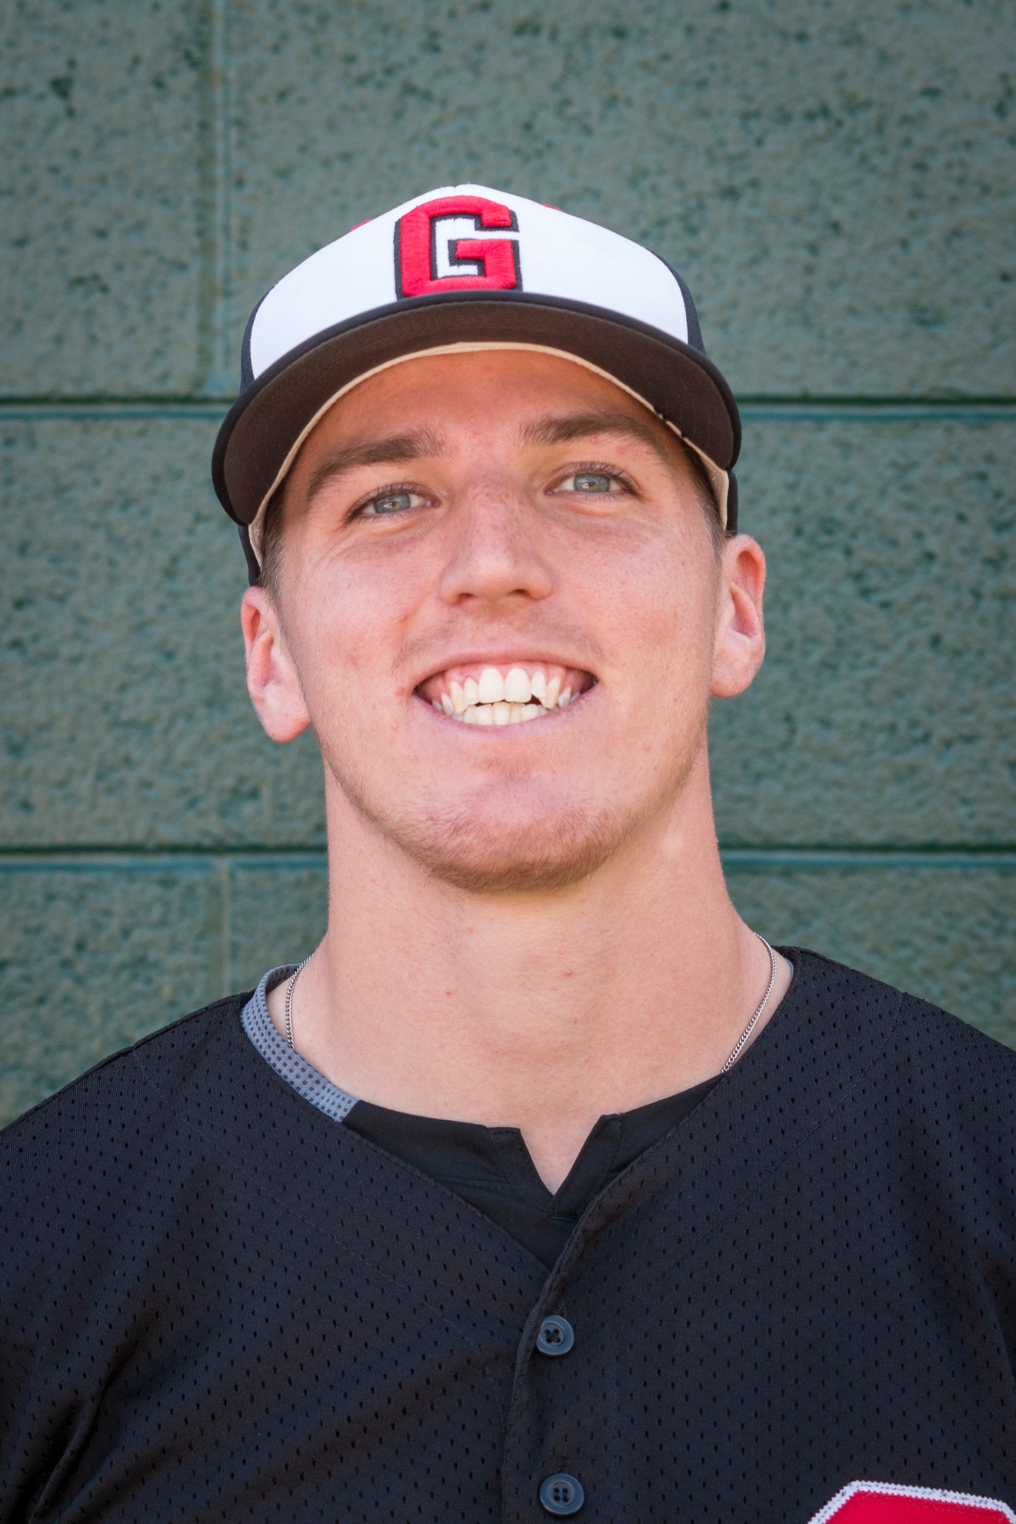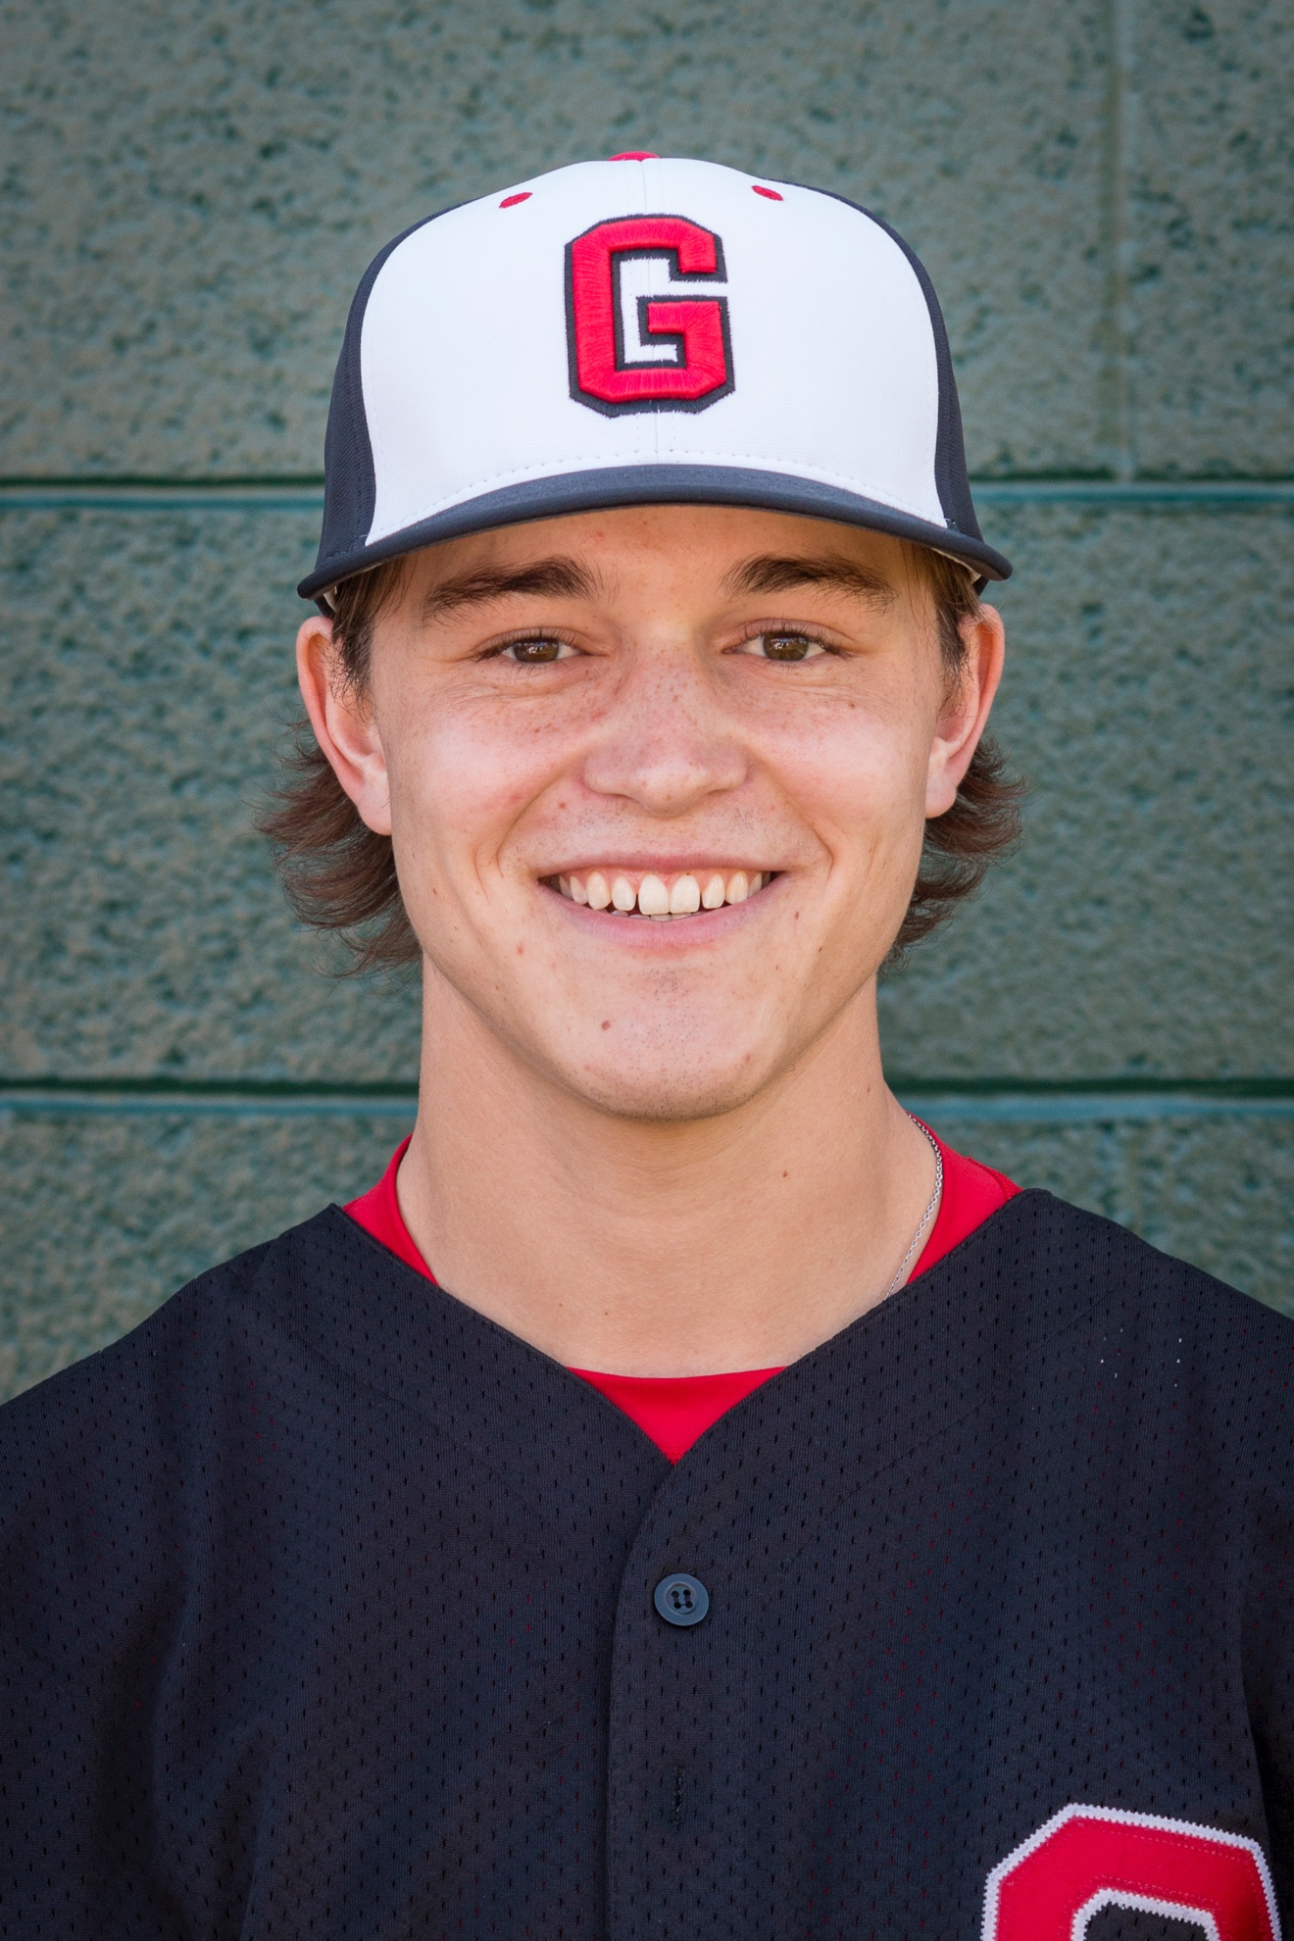
Dawson McCarville-Pittsburg Pirates Emmet Flood-Chicago White Sox

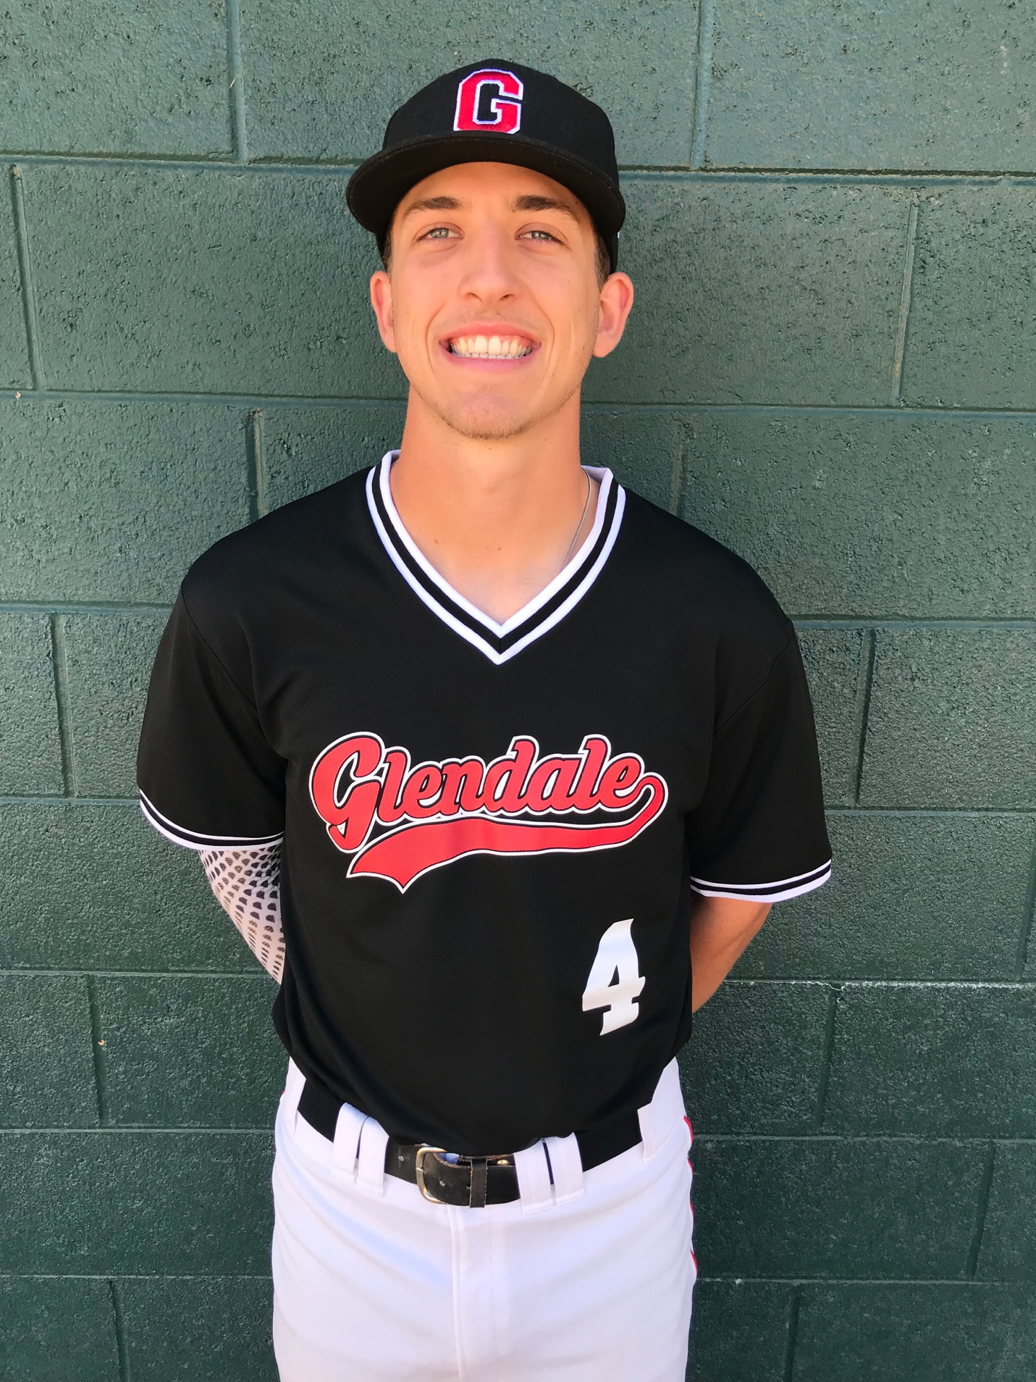
Beau Brieske(2018 GCC)-Detroit Tigers

We are very proud of you guys and all of our GCC players!
#gauchonation

Baseball ACCAC All Conference Team

ACCAC 1st Team All-Conference and 1st Team All Region
Congratulations to Dawson McCarville and Cade Biddle

ACCAC 2nd Team All-Region
Congratulations to Tyler Hajjar and Kobie Tinsley

Baseball Alumni
2019 GCC Baseball's list of transfers and pro-contracts signed over the last four years (.pdf)
Baseball transfers (2010-2019)
- Abilene Christian University- Riley Donahue 2017
- Adams State University- Dakota Solis 2017
- Arizona Christian College-Tommy Lay (P-Sandra Day O’Connor)-2013, Jon Pawling (C-Boulder Creek)-2013, Zac Livingston (C-Millennium) 2010
- Arizona State University- Sawyer Treese 2017
- Arkansas Tech- Camerson Shanks 2017, Nick Kovar 2018
- Ashland University-Tyler Pollock (IF-Colorado)-2012
- Avila University (KS)-Brian McNulty (P-Mountain Ridge)-2012
- Ball State University-Matt Haro (P-Shadow Ridge)-2014, Miles Moeller (P-North Canyon) 2011
- Benedictine University- Ivan Torres 2016, Dalton Heath 2019, Alfredo Amaya Zapata 2019
- Bethune Cookman University (FL)-Nick Rogers 2019
- Biola University-Jon Meyer (IF-Mountain Ridge)-2014
- Briar Cliff University (Iowa)-Alex Colegrove (IF-Campo Verde)-2014, Adam Webb (C-Sunrise Mountain)-2014, Tyler Vanderham 2016, Tyler Hill 2018
- Cal State University, East Bay-Bobby Bogensberger (IF-Canada)-2010
- Central Washington University-Alex Buya (OF-Coronado)-2014, Roger Amador (IF-Apollo) 2013
- Chapman University-Chris Watson (P-Notre Dame Prep) 2011
- Colorado Christian University- Cooper Gray 2016, Kyler Riordan 2018
- Colorado Mesa University-Joey Danner (P-Horizon) 2012, Jordan Moore-Leister (OF-Colorado) 2012, Wacy Crenshaw 2018
- Colorado State Pueblo- Mason Krueger 2017, Daniel Abiles 2018, Beau Brieske 2018, Nick Zappala 2018
- Eastern Michigan University-Tucker Rubino (IF-Horizon) 2012
- Faulkner University (AL) Nate Prokuski (P-Illinois)-2010
- Friends University (KS)-Brady Bowen (P-Verrado ) 2013, Brandon McMillin (P-Kingman)-2013
- Grand Canyon University (AZ)-Cameron Brendel (P-Boulder Creek)-2014, Jonny Abney 2017, Dawson McCarville 2019, Danny Kamins 2019
- Henderson State College (Arkansas)-Cody Jones (P-Boulder Creek)-2013
- Holy Names University (CA)-Noah Barros 2019
- Indiana Wesleyan University- Collin Ledbetter 2017
- Kansas Wesleyan University (KS)-Payton Deiters (IF-North Canyon)-2015, Caleb Wade (IF-Colorado) 2011, Chad Zuniga (C-Ironwood ) 2011
- Lamar University (TX) - Matt McDonald 2018
- Long Island University (NY) - Cade Biddle 2019, Josh Gainer 2019
- McPherson College (KS)-Chandler Rogers 2019
- Metro State University (CO)-Robbie Nickels (C-Horizon) 2010
- Mid-America Nazarene University (KS)-Dillon Moeller (IF-North Canyon) 2011
- Missouri Baptist University-Matt Harjung (IF-Chapparal)-2011
- New Mexico State University (NM)-Mitchell Allen 2018
- Northern Arizona University - Riley Kohler 2019
- Nyack College (NY)-Dylan Schantz (IF-Northwest Christian)-2013
- Ottowa University- Tyler Collins 2017, Hayden Sandman 2019, Kobie Tinsley 2019, Johnny Cherpak 2019,
- Pacific Univerisity- Casey Brown 2017
- Panhandle State University (OK)-Tyler Abrego (P-Sandra Day O’Connor)-2015
- Presentation College South Dakota- James Lewis 2016
- Regis University (CO)-Casey Kennedy (P-Greenway)-2014, Ryan Benedict (IF-Liberty) 2014, Garrett Skillings 2016
- Saint Cloud University (MN) - Tyler Hajjar 2019, Nick Brauns 2019
- Seton Hill University (PA)-Dylan Bonzo 2019
- Shawnee State University (OH) - Scott Walter 2019
- Sul Ross State (TX)-Tyler Mills (C-Gila Bend)-2013
- Texas A&M Kingsville (TX)-Jake Harner (P-Sandra Day O’Connor)-2015
- Texas Lutheran University-Jason Yarnell (P-Colorado)-2011
- Truman State University (MO)-Chris Zrostlik (IF-Willow Canyon)-2012
- University of Antelope Valley- Dallas Litscher 2016
- University of Arkansas Monticello- Sean Wagner 2016, Austin Brakebill 2016, Elijah Celaya 2018
- University of Sioux Falls (SD) - Zane Butts 2019
- University of Texas Permian Basin - Marcus Colgrove 2016
- University of Texas Rio Grande Valley - Hunter Lessard 2018
- University of New Orleans-Reese Kanter (OF-Horizon) 2012
- Viterbo University (WI)-Taylor Erwin (P-Willow Canyon) 2012
- Wayland Baptist University-Ethan Percell (OF-Greenway)-2014, Tyler Doolittle (C/P-Sandra Day O’Connor)-2012, Mike Cowan (IF-Deer Valley) 2012
- Western Oregon University-Houston Samuel (P-Mountain Ridge) 2014, Spencer Watkins (P-Horizon) 2012, Bennett Schilz (P-Goldwater) 2012
- Westmont College (CA)-Austin Trujillo (Boulder Creek)-2012
- York College (NE)-Junior Carrizoza (IF-Trevor Browne)-2011

Signed Professional Baseball Contracts (2010-2019)
- Jesus Azuaje- Philadelphia Phillies (25th Round)
- Brady Bowen (P-Verrado)-St. Louis Cardinals
- Dylan Brock (P-Millennium)-Milwaukee Brewers
- Zac Livingston (C-Millennium)-Los Angeles Angels
- James Lynch (OF-Connecticut)-Toronto Blue Jays
- Dallas Litscher (P-Sunrise Mountain)-Baltimore Oreoles
- Beau Brieske-Detroit Tigers
- Dawson McCarville-Pittsburg Pirates
- Emmet Flood-Chicago White Sox

University and Professional Baseball Careers (1980-2009)
- University of Arizona: Dave Brockman – P (North Canyon) – 2000 Matt Tatum – P (Thunderbird) – 2000 Don Pruitt - P (Thunderbird) – 1988 Rick Whalen – OF (Brophy) – 1987
- Arizona State University: Aaron Kramer – P (Goldwater) – 1995 Travis Flowers – IF (Moon Valley) – 1994 Paul LoDuca – C (Apollo) – 1992 Billy McGonigle – OF (Apollo) – 1992 Noah Peery – P (Deer Valley ) – 1992 Mike Rensmeyer – P (Deer Valley) – 1991 Gary Tatterson – P (Sunnyslope) – 1989
- Arkansas-Little Rock: Scott Lopez – P (Coronado) – 1992
- Armstrong Atlantic University (Georgia): Jeremy Olson – P (Mountain Ridge) – 2001 Jimmy LaRose – OF (Texas) – 1998
- Azusa-Pacific: Mark LeFevre – IF (Cactus) – 1984
- Ball State University: Miles Moeller-LHP/OF (North Canyon) – 2011
- Baylor University: Erik Boisjoly – IF (Canada) – 1996
- Benedictine College (Kansas): Matt Wiggins – P (Camelback) -1998 Craig Dial – P (Thunderbird) – 1997
- Bethany College (Kansas) Geronimo Ramirez – IF (Cesar Chavez) – 2005 Andy Spirek – OF (Grand Junction) – 2005 Joseph O'Donnell – P (Ironwood) – 2007
- Bmidji State (Minnesota) Rich Bohannon – IF (Millenium) -2005
- Briar Cliffe University (Iowa) Duffy Paulson – OF (Brophy) – 1994
- Cal State Dominguez Hills Andy Swaithes – P (Ironwood) – 2000
- Cal State East Bay Brock Butts – IF (Greenway) – 2008 Bobby Bogensberger-LHP (Canada) – 2010
- Coastal Carolina College Jared Grainger – P (Horizon) – 2003
- College of the Southwest (New Mexico) Jerry Backus – IF (Deer Valley) – 1987 Thomas Hills – P/OF (Alhambra) – 2004
- Concordia University (California) Seth Myers – 1B (Sunnyslope) – 1996 Todd Folger – P (Arcadia) – 1996 Derek Bondo – P (Washington State) – 2006 Dante Beltramo – OF (Sunrise Mountain) – 2007
- Creighton University Chris Marchildon – P (Brophy) – 2005
- Eastern Illinois University Shane Hesse – IF (Cactus) – 1993
- Eastern Michigan University Tucker Rubion – IF (Horizon) – 2010
- Eastern New Mexico Paul Burns – OF (Apollo) – 1997 Brian Cronk – 1B (Mingus) – 1997
- Emporia State (Kansas) Mike Casadei – IF (Chapparal) – 1999 Nick Redondo – IF (Deer Valley) – 1998 Scott Miller – 1B (Moon Valley) – 1998 Steve Claiborne – 1B (Alhambra) – 1996
- Faulkner University Nate Prokuski-LHP (Illinois) – 2010
- Florida – University of Greg Catalanotte – OF (Goldwater) – 1997
- Fort Hays State (Kansas) Stan Sweeney – OF (Deer Valley ) – 1986
- Francis Marion University (South Carolina) Martin Gordon – OF (Desert Vista) – 2008 Matt Broderick – LHP (Sandra Day O'Conner) – 2010 Zac Livingston – P/C (Millennium) – 2010
- Georgia State College Jay Clark – P (Idaho) – 2007
- Glassboro State (New Jersey) Fred Bianculli – IF (New Jersey) – 1984
- Gonzaga University Kemp Quackenbush – IF/P (Deer Valley) - 2001 Michael Rhodes - OF (Ironwood) – 2006
- Grand Canyon University Andy Rocha – P (Sunnyslope) – 2008 Jay Green – C (Horizon) – 2008 Taylor McGegor – IF (Sunrise Mountain) – 2008 Cody Wright – OF (Cactus) – 2004 Justin Rosko – IF (Sunrise Mountain) – 2004 Ben Belanger – P (Deer Valley) – 2003 Kyle Holtorf – P (Peoria) – 2003 Jake Wright – OF (NW Community Christian) – 2001 Devin Perrin – P/IF (Apollo) – 2001 Greg Serrano – IF (Ironwood) – 2001 Dave Brockman – P (North Canyon) – 2000 Trent Otis – IF (Agua Fria) – 2000 Mike Wojtkowski – OF (Peoria) – 2000 Rickie Holtorf – P (Greenway) – 2000 Brian Manoukian – OF (Nevada) – 1999 Rick Kerns – IF (Cactus) – 1994 Ryan Holtorf – OF (Greenway) – 1996 Kevin Borg – P (Deer Valley) – 1995 Josh Hurst – IF (Apollo) – 1991 Brian Lundberg – P (Peoria) – 1991 Tim Florez – IF (California) – 1989 Rob Ferguson – P (Deer Valley) – 1989 Anthony Farinacci – IF (Independence) – 1988 Victor Solis – IF (Brophy) – 1988 Kurt Kasik – C (Washington HS) – 1987 Kirk Moyer – OF (Colorado) – 1987 Craig Dolittle – P (Washington HS) – 1987 Joe French – OF (Brophy) – 1986 Dan Williamson – P (Tolleson) – 1984 Buck Holmes – IF (Coronado) -1983 Rick Sowell – IF (Greenway) – 1980 Brent Wilde - OF (Trevor Browne) – 1981 Brian Godbehere - P (Trevor Browne) – 1981 Bill LaCount – P (Trevor Browne) – 1981 Randy McCament – P (Greenway) - 1982
- High Point University (Tennessee) Wally Scott – P (Washington) – 2006
- Indiana State Dan Angulo – OF (Brophy)
- Iowa State University Joe Stanisz – P (Indiana) – 2000
- Iowa Wesleyan Josh Clousner – SS (Pinnacle) – 2005 Tod Nissle – C (Paradise Valley) – 2010
- Kansas Duane Thompson – IF (Cactus) – 1998 Chad Schuster – P (Apollo) – 1997 Craig Huthmacher – 1B (Moon Valley) – 1994
- Kansas Wesleyan University David Lovett – OF (Corona del Sol) – 2007 Chad Zuniga – C (Ironwood) – 2011 Caleb Wade – IF (Colorado) -2011
- Lamar University (Texas) Mike Bondanza – IF (Greenway) – 1990 Greg Walkup – C (Colorado) – 1983
- LaVerne Tyson Asay – OF (Utah) – 2004
- Lewis –Clark State College Daniel Anguiano – SS (Alhambra) – 2007 Pedro Ramos – P (Centennial) – 2009
- Loyola Marymount University Jeremy Lamell - OF (Chapparal) – 2006
- Louisiana-Lafayette Ben Belanger – P (Deer Valley) – 2003
- Lubbock Christian Kevin Rowland – P (Peoria) – 1983 Rod Briggs – P (Sunnyslope) – 1983
- Lyon College (Arkansas) Jim Shields – OF (Westview) – 2002
- Mesa State College (Colorado) Monte Knuth – IF (Buckeye) – 2003 Daryl Schaefer – OF (Agua Fria) – 1996 Donnie Baniewicz – IF (Cortez) – 1992 Mark Carlin – IF (Moon Valley) – 1992 Eric Lamb – P (Sunrise Mountain) – 2006
- Metro State College (Colorado) Robbie Nickels – C/OF (Horizon) – 2010
- MidAmerica Nazarene Dillon Moeller-IF (North Canyon) – 2011
- Missouri Baptist University Matt Harjung – 1B (Chapparal) – 2011
- Missouri Western State University Cody Miller-Tipton – OF (Willow Canyon) – 2008 Justin Stone – 1B (Sandra Day O'Connor) – 2007
- Morehead State (Indiana) Reid Kittelson – P (North Dakota) – 2004
- Nevada – Las Vegas (UNLV) Scott Suraci – OF (Scottsdale Saguaro) – 1999 Scott Flood – 1B (Apollo) – 1984
- Nevada – Reno Eddie Bonine – P (Mountain Ridge) – 2001 Brian Pendgraft – IF (Greenway) – 1989 Nolan Litke – C (Desert Vista) – 2006
- New Mexico Chris Armstrong – P (Apollo) – 1997 Jay Green – C (Horizon) – 2008
- New Mexico Highlands University Ben Dubin – IF (Horizon) – 2003 Thomas d'Angelis – OF (Brophy Prep) – 2008
- New Mexico State University Thomas Brendel – P (Goldwater) – 2009
- New Orleans, University of Paul Hatcher – IF (Shadow Mountain) – 1991 Drew Anderson – OF (Bradshaw Mountain) – 2005
- Nichols State (Louisiana) Brandon Vasconcellos – IF (Goldwater) – 1997 Michael Muscato – C (Mountain Ridge- 2004 Aaron Turano – P (Mountain Ridge – 2004
- North Alabama Don Gardner – OF (Greenway) – 1984
- North Carolina State Greg Serrano – IF (Ironwood) – 2001
- Northern Arizona University Matt Ruckle – OF (Parker) – 1981
- Northern Colorado Jim Baker – OF (Cortez) – 1989 Kort Miner – C (Colorado) – 1987
- Northwestern Oklahoma State University Chris Russell – OF (Boulder Creek) – 2010
- Northwestern State University (Louisiana) Jamie Kissner – IF (Oregon) – 2001
- Northwoods University (Michigan) Mike Capuano – P (Brophy Prep) – 2006 Josh Perry – P (Agua Fria) – 2006
- Oklahoma City University Travis Flowers – IF (Moon Valley) – 1994 Gregg Neumann – C (Illinois) – 1994
- Oklahoma State Steve Nichol – P (Iowa) – 1989
- Olivet Nazarene (Illinois) Josh Brill – P (Ironwood) – 2006
- Peru State (Nebraska) Matt Davis – OF (Sunrise Mountain) – 2006
- Point Loma University (California) Glenn Gilhuber – P (Illinois) – 2000 Ron Solares – C (Apollo) – 1990
- Portland University Wade Hickson – OF (Canada) – 1999
- Redlands University Billy Lavelle – IF (Brophy Prep) – 2006
- San Diego (UCSD) David Pruitt – C (Moon Valley) – 2002
- San Francisco, University of Luke Gradishar – IF (Colorado) – 1999
- Southern California (USC) Paul Cruz – OF (Peoria) – 1994
- Sterling College (Kansas) Ron Smith – IF (Goldwater) – 2003
- Southern Nazarene University (Oklahoma) Eric Davis – IF (Buckeye) – 2000
- Tarleton State University (Texas) Thomas de Angelis – OF (Brophy) – 2008
- Texas A&M Brett Weinberger – OF (Cactus) – 1990
- Trevecca Nazarene (Tennessee) Ryan Mieszala – OF (Greenway)
- Union University (Tennessee) Bryan Wagner – P (Thunderbird)
- Virginia Tech David Cross – P (Chaparral) – 2005
- Washington, University of Miles Kizer – C (Goldwater) – 2009
- Washington State University Eddie Bonine – P (Mountain Ridge) – 2001
- Wayland Baptist (Texas) Dan Planeta – OF (Coconino) – 2002 Calen Laos – IF (Ironwood) – 2001 Josh Milner – C (Deer Valley) – 2001 Richard Cruz – P (Agua Fria) – 2004
- Western Oregon Nick Miller – P (Mountain Ridge) – 2003
- Westmont College (California) Blake Edwards – OF (Coronado) – 1992 Chad Benson – IF (Paradise Valley) – 1990 Jeff Ludwig – P (Washington HS) – 1987 Dan Angulo – OF (Brophy) – 1984 Ed Trujillo – C (Trevor Browne) – 1984
- West Texas A & M Eric O'Brien – 3B (Cactus) – 2008 Andy Rocha – P (Sunnyslope) – 2008
- Wright State (Ohio) Travis Migliorini – SS (Mountain Ridge) – 2004
- Wyoming Todd Hall – IF (Wyoming) – 1988 Jeff Huson – IF (Mingus) – 1983 John Lacy – 1B (Flagstaff) – 1981 Jimmy Robinson – C (Cactus) – 1990
- York College Junior Carrizoza – IF (Trevor Browne) – 2011

Professional Baseball Contracts
- Atlanta Braves Chris Gongora – P (Apollo) – 1994 Kevin Haeberle – P (NW Community Christian) – 1989
- Baltimore Orioles Mikey Planeta – OF (Willow Canyon) – 2009
- Chicago Cubs Jeff Ludwig – P (Washington HS, Westmont)- 1987
- Cincinnati Reds Scott Dodd – P (Greenway) – 1990
- Colorado Rockies Greg Catalanotte – OF (Goldwater, Florida) – 1997
- Detroit Tigers *Eddie Bonine – P (Mountain Ridge) – Nevada Reno, Washington State
- Florida Marlins * Paul LoDuca – C (Apollo, ASU) – 1992
- Houston Astros Chase Lehr – P (Centennial) – 2008 Drew Anderson – OF (Bradshaw Mountain, New Orleans) – 2005
- Los Angeles Dodgers * Paul LoDuca – C (Apollo, ASU) – 1992
- Milwaukee Brewers Don Pruitt – P (Thunderbird, U of A) – 1988 Bill McGonigle – OF (Apollo, ASU) – 1992
- Montreal Expos Devin Perrin – P (Apollo, Grand Canyon) – 2001 *Jeff Huson – IF (Mingus, Wyoming) – 1983
- Minnesota Twins Chris Marini – P (Ironwood) – 2003
- New York Mets Derek Baker – P (Thunderbird) – 1993 *Paul LoDuca – C (Apollo, ASU) – 1992
- Philadelphia Phillies Shelby Rama – P (Thunderbird) – 1992 Brian Lundberg – P (Peoria, Grand Canyon) – 1991
- Pittsburgh Pirates Brent Klinger – P (Greenway) – 2008
- San Diego Padres *Eddie Bonine – P (Mountain Ridge, Washington State, Nevada-Reno) John Slamka – P (Apollo) – 1994 Kelly Lifgren – P (Moon Valley) – 1988
- Saint Louis Cardinals Dave Brockman – P (North Canyon, U of A, Grand Canyon) – 2000
- San Francisco Giants Chris Armstrong – C (Apollo, New Mexico) – 1997 Tim Florez – IF (California, Grand Canyon) – 1989 *Randy McCament – P (Greenway, Grand Canyon) – 1982
- Seattle Mariners Clay Klavitter – OF (Deer Valley) – 1990 Mark Brakebill – IF (Moon Valley) – 1989
- Texas Rangers Mark Finney – P (Deer Valley) – 1990

Played in the Major Leagues
Summary - 80 different colleges and universities attended by 170 student-athletes - 31 players have signed professional baseball contracts; 5 have reached the major league level.

